English Martyrs Catholic Church
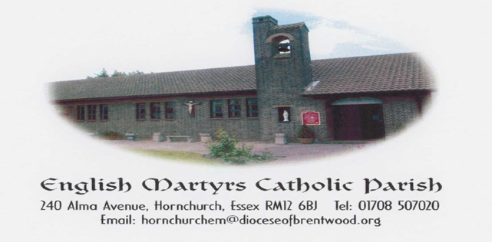
http://www.englishmartyrshx.com/
Parish Priest: Fr Linu Thankachan
240 Alma Avenue, Hornchurch, Essex RM12 6BJ
Tel.no: 01708 507020
email: hornchurchem@brcdt.org
Founded 1955 Diocese of Brentwood Registered Charity No. 23409

PRAYER FOR OUR DIOCESE
Lord Jesus Christ
Son of the Living God.
Teach us to walk in your ways more trustfully
To accept your truth more faithfully
And to share your life more lovingly
Inspire us by the power of the Holy Spirit
for mission within our Diocese
so that your name may be made known
and that all may come as one family
to the Kingdom of the Father
where you live for ever and ever. Amen

FIRST SUNDAY OF ADVENT
SUNDAY 3RD DECEMBER 2023 (B)

Isaiah 63:16-17; 64:1.3-8 1 Corinthians 1:3-9 Mark 13:33-37

This First Sunday of Advent opens with a selection from the Book of Isaiah. More specifically, within these verses, we hear the plea of community members shortly after their return from exile. The rousing words of an earlier prophet who had proclaimed incredible words of hope must have seemed like false promises to the Jews, whose homeland was far from what they had envisioned it would be. In a verse that is not part of the lectionary reading, God is asked: “Why have our enemies trampled your sanctuary?” (Is 63:18).

The brief selection from Mark reminds us that we are indeed in the season of Advent. We are told to be watchful and alert while we await the coming of Christ. Although Mark’s message was first addressed to Christians of the first century, we too are invited to actively await the kingdom of God.

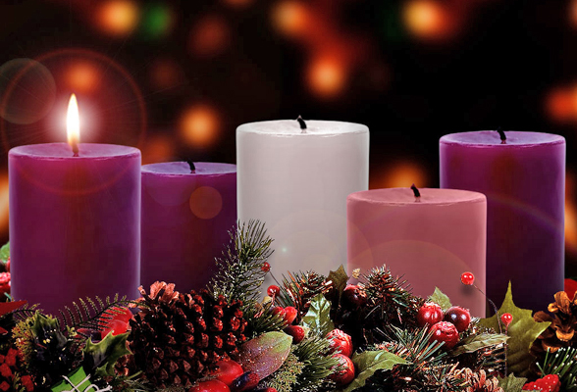
This Photo by Unknown Author is licensed under CC BY-NC-ND

PRIMARY SCHOOL APPLICATIONS FOR SEPTEMBER 2024: To obtain a Certificate of Catholic Practice, Fr Linu will be available to see parents on Thursday 7th December, between 6.30 pm and 7.30 pm. Parents will be seen on a first come first served basis. Please wait in the Church. Thank you.

ADVENT RECONCILIATION SERVICE:
In preparation for the celebration of the Birth of Our Lord, our Parish will be hosting a Reconciliation Service Wednesday 20th December 6.30pm-8.00pm. (English & Malayalam)

SOCIAL COMMITTEE: The raffle will be drawn after mass at the coffee morning in the lounge today 3rd December. There will be no coffee morning on Sunday 31st December.

A CHRISTMAS MESSAGE FROM THE STAFF AND TRUSTEES OF BRENTWOOD CATHOLIC CHILDREN’S SOCIETY: We would like to wish everyone across Brentwood Diocese a very happy and blessed Christmas. As we prepare to celebrate our 40th year in 2024, we would like to thank everyone who has supported our work by making a donation at one of the parish crib scenes across the Diocese since the charity was formed. This steadfast support has allowed us to give hope to thousands of children, young people and families by offering them the specialist care they need. Thank you all.

ST JOSEPH’S SCHOOL: Dear Parishioners, we are currently trying to recruit new full time and relief lunchtime middays at St Joseph's. This is such an important and valued role in school. The hours would be from 11.55-1.15 and would involve supporting the children on the playground and while eating their lunch. We are looking for full time middays which is 5 days a week but also part time relief middays, who can offer less time or cover when we have staff sickness. If you are interested in applying please visit the School office during school hours or alternatively you can phone on 01708 220277 or email office@st-josephs.havering.sch.uk.

BCYS YOUTH MASS: Thursday 7th December 2023, 6pm at Brentwood Cathedral
Beginning with pizza & refreshments in the Parish Hall from 6pm, and an Advent Reconciliation service in the Cathedral before Mass. Youth Mass will then be celebrated in the Cathedral at 7:30pm. Absolutely everyone is welcome, please bring instruments, and sing, serve or read if you wish! No need to book, but do let us know if you have a group coming – just email info@bcys.net

THE DIVINE MERCY APOSTOLATE LONDON: is holding a Divine Mercy Advent Reflection 2023 at the Church of Mary Mother of God 192 Nags Head Road, Ponders End, Enfield EN3 7AR on Saturday 16 December 2023 from 1:30 pm to 4:30 pm led by the Marian Fathers. The Retreat will include teachings on the Message of Mercy, Stations of the Cross, Holy Mass, Hour of Mercy with Adoration and Benediction and Veneration of the Image of Merciful Jesus. All Welcome. Please call Millie on 07957594646 for more information.

THE UNIVERSE CATHOLIC WEEKLY: True to its mission of being “a light to guide the world, and a mirror to reflect it” Keeping Catholics informed about their faith and bringing them ever closer to God. To keep our high standard going and maintain a strong weekly catholic voice at a time when it is such needed in the world. The newspaper will be available during the first week of December for £3.50. Please put in the box marked ‘Catholic papers/books’. Many thanks.

BISHOP’S CERTIFICATE IN CATECHESIS AND YOUTH MINISTRY: is an online course is designed to be an entry level qualification to help in the ongoing formation of adults involved in sacramental preparation (First Holy Communion and/or Confirmation) or youth ministry in the Diocese of Brentwood. It includes both the development of practical skills & the deepening of theological knowledge. For more information or to register your interest please email clairebailey@brcdt.org or see the website https://bcys.net/bishops-cert/

DIOCESAN DIRECORY: We have copies at the back of the church of our Diocesan Directory. The price this year is £2.95.

SAHARA DESERT RETREAT IN MOROCCO: 26 February – 11 March 2024
Including a day visiting Marrakesh and 9 full days in the Desert. With Fr Arnaud and Deacon Vladimir from St Antony’s in Forest Gate. Designed for young adults, open to all adults able to hike 4 - 6 hours a day for 9 full days in the desert. £952 (plus flight). www.desert-retreat.com or phone Catherine at 07807 348223.

PLEASE PRAY FOR THE SICK AND HOUSEBOUND IN OUR PARISH:
Theresa Camilleri, Maureen Chaliss, Fergal Clerkin, Anna Heneghan, Brenda Humphreys, Colin Johns, George Malaj, Margaret, Eileen McCaffery, Sheila McCurdy, Doris Mizzi, Sheila Murphy, Sheila Nugent, Mary O’Hagan, Rachel, Pradeepan Ragunathan, Mary Scully, Greta Street, Voni Tesi, Rose Yates, Claire Ryan in Emerson Court.

ANNIVERSARIES OCCURRING AT THIS TIME – OCTOBER/NOVEMBER:
David Calder, Iris Canning, Marie Coxell, Johni Deely, Phil Fowley, Tommy Goggin, Evelyn Golding, Paul Hogan, Bridie Long, Paul McAvoy, Patrick Markey, Sidney Meadway, Don Muscat, Ann O’Connor, Geraldine Patterson, Charles Poddington, Judith Salisbury, Eamon Shanahan, Peter Soares, Rose Soares, Denis Sullivan, Monsignor Van Meenan, Carlos Vieira, Dr Michael Wright

PARISH FINANCE:

Offertory Collection: The weekly collection for the 26.11.23 was as follows:

Main Collection: £280.60 (Envelopes: £115, LP: £165.60)
National Youth Sunday: £133.90 (Envelopes: £50.00, LP: £83.90)
Christmas Flowers donation: £100 (Gift Aided)
Repository: £20
Candles: £7
Newspapers: £3
Mass Offerings: £20
Funeral Donation: £235

Total: £799.50

We would like to encourage you to make your contributions using a Standing Order rather than cash. There are Standing Order forms at the back of the Church. Our bank details are: HSBC Account Name: Catholic Church Hornchurch English Martyrs. Account No. 11019198 Sort code 40 13 22.

Sunday 3rd December – Sunday 10th December

Sunday 3rd December First Sunday of Advent (B)
10.00 am Kathy Driver – RIP (Maria Poddington)

Monday 4th December Feria
9.00 am Arul Dhas – RIP/Anni (Claret)

Tuesday 5th December Feria
9.00 am

Wednesday 6th December Feria
9.00 am Eucharistic Service

Thursday 7th December St Ambrose, Bishop, Doctor of the Church
9.00 am For Parishioners

Friday 8th December The Immaculate Conception of the
Blessed Virgin Mary – Solemnity
9.00 am Mr and Mrs A Dani & Mr Z Dani – RIP (Maria P)

Saturday 9th December Feria
9.00 am No Mass

Sunday 10th December Second Sunday of Advent (B)
10.00 am Michael John Curry – RIP (Graham & Sally)

Parish Priest: Fr Linu Thankachan (01708 507020)
Parish Administrator: Daphne Thomas, Mon, Tues, Thurs & Fri (10am-1pm) (01708 507020)
Pastoral Team Leader: Graham Daniels (07542 588763)
Steward of the Gospel: Mandy Meadway (07801 470516)
Parish Finance: Mrs Stephanie Mallen (07983 962465), Marie Browne (07443 362654)
Diocesan Safeguarding Representative: Katie Nash (07825 293308)
Hall & Lounge Bookings: English Martyrs Parish Office (01708 507020)
Church & Hall Caretaker: Mike Dineen (07415 727926)
Legion of Mary: Michael Okafor (07956 586370)

Sunday Mass 10.00 am
Weekday Mass 9.00 am (Mon, Tues, Thurs, Fri)
Holy Days of Obligation 9.30 am
Confession on Friday 9.30 am – 10.00 am
Legion of Mary After Sunday morning mass (11.30 am onwards)
Baptisms By Appointment (Saturdays 12.00 pm - 12.30 pm)

