English Martyrs Catholic Church
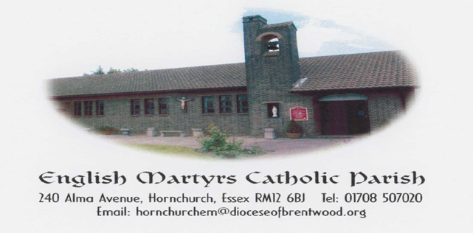
http://www.englishmartyrshx.com/
Parish Priest: Fr Linu Thankachan
240 Alma Avenue, Hornchurch, Essex RM12 6BJ
Tel.no: 01708 507020
email: hornchurchem@brcdt.org
Founded 1955 Diocese of Brentwood Registered Charity No. 23409

PRAYER FOR THE SECOND SUNDAY OF ADVENT
Merciful God, you sent John the Baptist
to preach repentance. Forgive us for the
times when we have done wrong, when we
have hurt other people and damaged our earth.
Lead us to make a change, to live differently,
preparing a way and making your paths straight.
Amen.

THIRD SUNDAY OF ADVENT
SUNDAY 17TH DECEMBER 2023 (B)

Isaiah 61:1-2, 10-11 1 Thessalonians 5:16-24 John 1:6-8, 19-28

For the third consecutive week, our first reading is from the Book of Isaiah. In today’s selection we hear the words of one who is called by God to be an instrument of God’s nurturing love to those most in need – the poor, the broken hearted, and those imprisoned and held captive.

Our responsorial psalm today is one of the most well-known poems of the New Testament, Mary’s Magnificat. The words are reminiscent of the song Hannah sings (1 Samuel 2:1-10) as she rejoices after having borne a son and offered him back to the Lord.

In Paul’s letter to the Thessalonian community, we hear a series of rapid commands: Rejoice. Pray. Do not quench the Spirit. Do not despise prophecy. Test everything. Paul then offers a brief but beautiful prayer that reminds us that God is always faithful.

Today’s Gospel, from John, hearkens back to last week’s Gospel, from Mark, where we were introduced to John the Baptist. Once again, we find ourselves at the beginning of a Gospel. Unlike Mark’s straightforward telling of the Baptist’s ministry, this Gospel presents the Baptist somewhat more mysteriously. He is one who came “to testify to the light”. When questioned by the authorities about his identity, his responses are “I am not” and “No”. Finally, John the Baptist identifies himself as the one who is preparing the way for one far greater than he. That one, although not named in this reading, is Jesus the Christ.

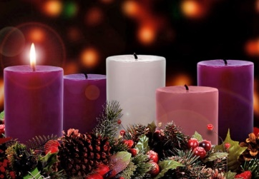
This Photo by Unknown Author is licensed under CC BY-NC-ND

RIP: We were very sad to hear that Eileen McCaffery passed away at Queens Hospital on Tuesday 5th December. Please remember her and her family in your prayers.

SPECIAL PRAYERS: Please remember in your prayers Patrick Hayes.

ADVENT RECONCILIATION SERVICE: In preparation for the celebration of the Birth of Our Lord, our Parish will be hosting a Reconciliation Service on Wednesday 20th December 6.30pm-8.00pm. (English & Malayalam)

SOCIAL COMMITTEE: There will be no coffee morning on Sunday 31st December.

OFFICE CLOSURE: The office will be closed from Monday 25th December to Friday 5th January inclusive. Messages can still be left on the answer machine however and Father will respond to the urgent ones.

CHRISTMAS OFFERING ENVELOPES: These are available for you to take home from the back of the Church. Just a reminder that the Offertory collection taken at the Christmas Masses is your personal gift to your Priest. Please continue to pray for Fr Linu and we thank him for his dedicated ministry to us. Your generosity, as always, is greatly appreciated. Many thanks.

PLEASE PRAY FOR THE SICK AND HOUSEBOUND IN OUR PARISH:
Theresa Camilleri, Maureen Chaliss, Fergal Clerkin, Patrick Hayes, Anna Heneghan, Brenda Humphreys, Colin Johns, George Malaj, Margaret, Sheila McCurdy, Doris Mizzi, Sheila Murphy, Sheila Nugent, Mary O’Hagan, Rachel, Pradeepan Ragunathan, Mary Scully, Greta Street, Voni Tesi, Rose Yates, Claire Ryan in Emerson Court.

ANNIVERSARIES OCCURRING AT THIS TIME – DECEMBER: Gerry Collins, Ben Cummins, Emildhary & Arul Dhas, Zoraida Egipto, Nancy Fagin, Tom Guidera, Alfred Medlin, Nicholas Medlin, Anne Pitt, Doug Taplin, Lazar Theresa, Carlos Viera, David Wright, Jonathan Wright.

PARISH FINANCE:

Offertory Collection: The collection for the 10.12.23 was as follows:

Main Collection: £249.72 (Envelopes: £44, LP: £205.72)
Candles: £10.78
Newspapers: £8.00
Christmas flowers: £50
Mass Intentions: £115 (Envelopes: £20, LP: £95)

The bank receipts for the period 06.11.23 - 05.12.23 were as follows:

Main Collection: £906 (GA: £651, Non-GA: £255)
Christmas Flowers: £10 (GA)
Hall bookings: £1,330
Total: £2,246

We would like to encourage you to make your contributions using a Standing Order rather than cash. There are Standing Order forms at the back of the Church. Our bank details are: HSBC Account Name: Catholic Church Hornchurch English Martyrs. Account No. 11019198 Sort code 40 13 22.

Christmas Octave Timetable 2023-2024

Sunday 24th December: The Nativity of the Lord
Sunday Mass 10.00 am
Christmas Family Mass 6.00 pm
Christmas Eve Carols 10.00 pm – 10.30 pm
Christmas Midnight Mass 10.30 pm

Monday 25th December: Christmas Day – Holy Mass
Christmas Morning Mass: 10.00 am

Tuesday 26th December: St Stephen, The First Martyr
Christmas Octave Mass: 9.00 am

Wednesday 27th December: St John, The Evangelist
Christmas Octave: 9.00 am Eucharistic Service

Thursday 28th December: The Holy Innocents
Christmas Octave Mass: 9.00 am

Friday 29th December: St Thomas of Canterbury
Christmas Octave Mass: 9.00 am

Saturday 30th December: Sixth Day within the Octave of Christmas
Christmas Octave: No Mass

Sunday 31st December: The Holy Family of Jesus, Mary & Joseph
(New Year’s Eve)
Holy Mass: 10.00 am

2024

Monday 1st January Mary Mother of God
New Year Day Mass: 10.00 am

Tuesday 2nd January Ss Basil the Great and Gregory
Nazianzen
Memorial Mass: 9.00 am

Sunday 17th December – Sunday 24th December

Sunday 17th December Third Sunday of Advent (B)
(‘Gaudete’ Sunday)
10.00 am Tom Guidera – RIP/Anni (Pauline)

Monday 18th December Feria
9.00 am Rt Rev Mons Van Meenen Ints

Tuesday 19th December Feria
9.00 am Mrs Dela Victoria – For a successful operation

Wednesday 20th December Feria
9.00 am Eucharistic Service

Thursday 21st December Feria
9.00 am Mrs Dela Victoria – For a successful operation

Friday 22nd December Feria
9.00 am James & Charles Poddington – RIP

Saturday 23rd December Feria
9.00 am No Mass

Sunday 24th December Fourth Sunday of Advent (B)
(Expectant Mothers)
10.00 am For Parishioners
6.00 pm Christmas Family Mass
10.00 – 10.30 pm Christmas Eve Carols
10.30 pm Christmas Midnight mass

Parish Priest: Fr Linu Thankachan (01708 507020)
Parish Administrator: Daphne Thomas, Mon, Tues, Thurs & Fri (10am-1pm) (01708 507020)
Pastoral Team Leader: Graham Daniels (07542 588763)
Steward of the Gospel: Mandy Meadway (07801 470516)
Parish Finance: Mrs Stephanie Mallen (07983 962465), Marie Browne (07443 362654)
Diocesan Safeguarding Representative: Katie Nash (07825 293308)
Hall & Lounge Bookings: English Martyrs Parish Office (01708 507020)
Church & Hall Caretaker: Mike Dineen (07415 727926)
Legion of Mary: Michael Okafor (07956 586370)

Sunday Mass 10.00 am
Weekday Mass 9.00 am (Mon, Tues, Thurs, Fri)
Holy Days of Obligation 9.30 am
Confession on Friday 9.30 am – 10.00 am
Legion of Mary After Sunday morning mass (11.30 am onwards)
Baptisms By Appointment (Saturdays 12.00 pm - 12.30 pm)

