English Martyrs Catholic Church
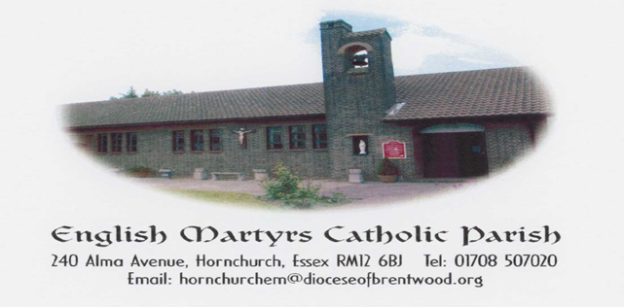
http://www.englishmartyrshx.com/
Parish Priest: Fr Linu Thankachan
240 Alma Avenue, Hornchurch, Essex RM12 6BJ
Tel.no: 01708 507020
email: hornchurchem@brcdt.org
Founded 1955 Diocese of Brentwood Registered Charity No. 23409

PRAYER FOR THE SECOND SUNDAY OF ADVENT
Merciful God, you sent John the Baptist
to preach repentance. Forgive us for the
times when we have done wrong, when we
have hurt other people and damaged our earth.
Lead us to make a change, to live differently,
preparing a way and making your paths straight.
Amen.

SECOND SUNDAY OF ADVENT
SUNDAY 10TH DECEMBER 2023 (B)

Isaiah 40:1-5, 9-11 2 Peter 3:8-14 Mark 1:1-8

What wonderful readings we hear on this Second Sunday of Advent! The text from Isaiah is often referred to as the opening of the “book of consolation”, a work attributed to a prophet who ministered near the end of the exile in Babylon. The announcement of the return to Jerusalem under the tender care of a loving God must have seemed too good to be true for a community living under the rule of the Babylonians, the people who had devasted both the holy city and temple and who were responsible for the circumstances of the exiles.

The opening lines of Mark’s Gospel account state clearly that what is to follow is good news about the Son of God. While Mark attributes the next two sentences to the prophet Isaiah, the quotation is actually a conflation of material about guarding or preparing the way in the Books of Exodus, Malachi and Isaiah. Although the author of Mark was quite familiar with the Old Testament, his quotations are not always in perfect sync with the most familiar texts. Nevertheless, this reading introduces John the Baptist, who in turn prepares us for the arrival of Jesus in the next scene in Mark.

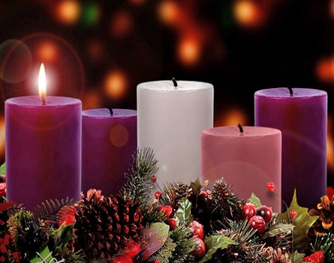
This Photo by Unknown Author is licensed under CC BY-NC-ND

PRIMARY SCHOOL APPLICATIONS FOR SEPTEMBER 2024: If any parents missed the date on 7th for obtaining a Certificate of Catholic Practice, please contact the office on 01708 507020. Thank you.

ADVENT RECONCILIATION SERVICE:
In preparation for the celebration of the Birth of Our Lord, our Parish will be hosting a Reconciliation Service on Wednesday 20th December 6.30pm-8.00pm. (English & Malayalam)

SOCIAL COMMITTEE: Many thanks to all who attended last Sunday’s coffee morning/raffle. What a success it was and well done to those who were lucky winners. Please continue to donate any biscuits and/or cakes to the Sunday coffee mornings. Many thanks. There will be no coffee morning on Sunday 31st December.

NEWHAM DEANERY DAY OF RECOLLECTION: ‘The New Year - Praying for Peace with Our Lady’ led by Fr. Stewart Foster on Saturday 30th December at Our Lady of Compassion Church, Upton Park E13 9BF : Mass at 9.15am, talk in the hall, Eucharistic Adoration with Benediction ending at 3pm. Please bring a packed lunch.

DIOCESAN DIRECORY: We have copies at the back of the church of our Diocesan Directory. The price this year is £2.95.

PLEASE PRAY FOR THE SICK AND HOUSEBOUND IN OUR PARISH:
Theresa Camilleri, Maureen Chaliss, Fergal Clerkin, Anna Heneghan, Brenda Humphreys, Colin Johns, George Malaj, Margaret, Eileen McCaffery, Sheila McCurdy, Doris Mizzi, Sheila Murphy, Sheila Nugent, Mary O’Hagan, Rachel, Pradeepan Ragunathan, Mary Scully, Greta Street, Voni Tesi, Rose Yates, Claire Ryan in Emerson Court.

ANNIVERSARIES OCCURRING AT THIS TIME – DECEMBER: Gerry Collins, Ben Cummins, Emildhary & Arul Dhas, Zoraida Egipto, Nancy Fagin, Tom Guidera, Alfred Medlin, Nicholas Medlin, Anne Pitt, Doug Taplin, Carlos Viera, David Wright, Jonathan Wright.

PARISH FINANCE:

Offertory Collection: The weekly collection for 03.12.23 was as follows:
Main Collection: £230.61 (Envelopes: £62, LP: £168.61)
Repository: £20
Christmas Flowers: £100 (GA)
Stipends: £20
Hall Bookings: £300
Coffee Morning Donation: £200
Christmas Raffle: £220

Total: £1,090.61

We would like to encourage you to make your contributions using a Standing Order rather than cash. There are Standing Order forms at the back of the Church. Our bank details are: HSBC Account Name: Catholic Church Hornchurch English Martyrs. Account No. 11019198 Sort code 40 13 22.

Christmas Octave Timetable 2023-2024

Sunday 24th December: The Nativity of the Lord
Sunday Mass 10.00 am
Family Mass 6.00 pm
Christmas Eve Carols with 10.00 pm – 10.30 pm
Midnight Mass 10.30 pm

Monday 25th December: Christmas Day – Holy Mass
Christmas Morning Mass: 10.00 am

Tuesday 26th December: St Stephen, The First Martyr
Christmas Octave Mass: 9.00 am

Wednesday 27th December: St John, The Evangelist
Christmas Octave Mass: 9.00 am Eucharistic Service

Thursday 28th December: The Holy Innocents
Christmas Octave Mass: 9.00 am

Friday 29th December: St Thomas of Canterbury
Christmas Octave Mass: 9.00 am

Saturday 30th December: Sixth Day within the Octave of Christmas
Christmas Octave Mass: No Mass

Sunday 31st December: The Holy Family of Jesus, Mary & Joseph
(New Year’s Eve)
Holy Family 10.00 am

2024

Monday 1st January Mary Mother of God
New Year Day Mass: 10.00 am

Tuesday 2nd January Ss Basil the Great and Gregory Nazianzen
Mass: 9.00 am

Sunday 10th December – Sunday 17th December

Sunday 10th December Second Sunday of Advent (B)
10.00 am Michael John Curry – RIP (Graham & Sally)

Monday 11th December Feria
9.00 am Pat Lark – RIP (T & F Bethell)

Tuesday 12th December Feria
9.00 am Joe O’Sullivan – RIP

Wednesday 13th December St Lucy, Virgin, Martyr
9.00 am Eucharistic Service

Thursday 14th December St John of the Cross, Priest, Doctor of the Church
9.00 am Leandra O’Sullivan – RIP

Friday 15th December Feria
9.00 am Michael John Curry – RIP

Saturday 16th December Feria
9.00 am No Mass

Sunday 17th December Third Sunday of Advent (B)
(‘Gaudete’ Sunday)
10.00 am Tom Guidera – RIP/Anni (Pauline)

Parish Priest: Fr Linu Thankachan (01708 507020)
Parish Administrator: Daphne Thomas, Mon, Tues, Thurs & Fri (10am-1pm) (01708 507020)
Pastoral Team Leader: Graham Daniels (07542 588763)
Steward of the Gospel: Mandy Meadway (07801 470516)
Parish Finance: Mrs Stephanie Mallen (07983 962465), Marie Browne (07443 362654)
Diocesan Safeguarding Representative: Katie Nash (07825 293308)
Hall & Lounge Bookings: English Martyrs Parish Office (01708 507020)
Church & Hall Caretaker: Mike Dineen (07415 727926)
Legion of Mary: Michael Okafor (07956 586370)

Sunday Mass 10.00 am
Weekday Mass 9.00 am (Mon, Tues, Thurs, Fri)
Holy Days of Obligation 9.30 am
Confession on Friday 9.30 am – 10.00 am
Legion of Mary After Sunday morning mass (11.30 am onwards)
Baptisms By Appointment (Saturdays 12.00 pm - 12.30 pm)

